BRIGHTWAY INSURANCE AN OVERVIEW OF WIND MITIGATION AND FOUR POINT INSPECTIONS

Brightway Insurance | 11/3/22

Contents
1. What is a Wind Mitigation Inspection? 2
2. Who completes a wind mitigation inspection? 2
3. How are wind mitigation credits applied? 3
4. Common Mistakes in Wind Mitigation Inspections 3
5. Required Documentation 4
6. What is a Four-Point Inspection? 4
7. Why Does an Insured Need a Four-Point Inspection? 5
8. Required Documentation 5
9. How to submit the Four Point Inspection or Wind Mitigation Inspection documents to the carrier for processing 5

Brightway Insurance
An Overview of Wind mitigation and Four Point Inspections

What is a Wind Mitigation Inspection?

Wind mitigation is the process of adding features to a home that help withstand or increase resistance to high winds caused by a major storm or hurricaneWind mitigation is meant to avoid a hazard by reducing the amount of damage to the customer’s home and reducing the amount of debris that may result in damage to other homes and speed cleanup efforts.
Homeowners can receive substantial credits for outfitting their homes with windstorm mitigation features.
According to Florida Statute 627.0629, all insurance companies are required to offer Florida homeowners “discounts, credits, or other rate differentials...” for particular construction techniques that help to reduce wind damage caused by hurricanes, tropical storms and other windstorms related claimsWhat does the inspection specifically review?
During a wind mitigation inspection, the inspector will examine several areas of the home, looking for features that improve the home’s wind resistance.
- Was the structure built in compliance with the Florida Building Code?
- Roof covering
- Roof deck attachment
- Roof to wall connection
- Roof shape
- Water resistancee
- Opening protection

Who completes a wind mitigation inspection?

The following licensed individuals are able to complete a wind mitigation inspection at the customer’s expense:

- Home Inspector
- Building Code Inspector
- General, Building or Residential Contractor A Professional Engineer
- A Professional Architect

How are wind mitigation credits applied?

Every home insurance company in Florida must offer Wind Mitigation discounts. However, there is no standard amount for each of the 7 credit earning items, nor is there any scientific data used to determine how much credit each carrier awards for each item

Example: Carrier A might give a 5% discount for having “Clips” in item 4, but Carrier B might offer only 1% or as much as 10%

These discounts are also often only applied to the “Wind” portion of your premium: Say your insurance costs $1,000.00 per year, it is then broken down into “Wind” and “Non-Wind” portions. Again, there is no standard amongst carriers for that split, so there is no way to substantiate it on a common level for all homeowners

Common Mistakes in Wind Mitigation Inspections

Occasionally a wind mitigation inspector may provide photos that are not clear

- Photos are usually required to validate credits
- Also the photos must be in color
- Customers should not fax wind mitigation photos

Occasionally, the form is submitted incomplete, the wind mitigation must have the following:

- Signature and licensing information of inspector
- Company and contact information of inspector
- Signature of named insured (commonly missing)
- Initials of inspectors on each page

Occasionally a customer may ask for a quote on the discount that they will be provided for mitigating their home

- The Service Department cannot quote these discounts nor should we promise that mitigating the home will provide discounts
- Advise the customer that the discounts will be determined based on the inspector’s report and Underwriter’s review

Required Documentation

The insurance company’s Underwriting department will require the following:

- Colored photos of all inpsection points (1-7 under 1. What is a Wind Mitigation Inspection?)
- Initials, Signature, and Date of the Inspector and Signature and Date of the Insured

Below is a link to a copy of a completed Wind Mitigation Inspection.
Completed Wind Mitigation Inspection

What is a Four-Point Inspection?

A Four-Point Inspection is essential to determine and present proof to the insurance company of system conditions, updates, and life expectancy for the four major components of the property, which include roofing, electrical, plumbing, and the heating and cooling system. A Four-Point Inspection is often a required inspection in order to obtain (or maintain) insurance coverage. The inspection requirements were designed by insurance companies in order to get a better understanding of the structure they are insuring.

Four-point inspections tend to be more prevalent in coastal states, specifically in Florida and Texas. Coastal areas experience more inclement weather that leads to catastrophic devastation. This prompts lawmakers to frequently update building codes. Homes built 40 or more years ago were made in accordance to different standards than those built today, which is why they may not be considered as safe as more modern homes.

Carriers may request a four-point inspection from the Insured to avoid a cancellation or non-renewal of an existing policy. These are usually paid out at the Insured’s expense. Four-Point Inspections are not the same as Wind Mitigation Inspections.

A “Four Point Inspection” focuses only on four main areas of interest in a home:

- Electrical Wiring and Panels
- HVAC (Heating, Ventilation, and Air Conditioning)
- Plumbing
- Roof

Why Does an Insured Need a Four-Point Inspection?

Insurance companies require four-point inspections on older homes before issuing a policy. Older homes may have used construction techniques or materials that were normal at the time, but were subsequently phased out in favor of more modern practices.

Their common concern is that there may be conditions in an older home that could become a liability to them. For instance; a home with a roof nearing the end of its reliable service life may fail while under the policy and the homeowner may seek reimbursement from their insurance company for damages to the home or its contents. If the four points assessed on the inspection are in poor condition, in need of being updated or replaced or were improperly installed, they may fail and cause fire or water damage to a home.

Newer homes are assumed (by the insurance companies) to not have these problems as frequently as older homes.

8. Required Documentation

There is no industry wide standard form for a Four-Point Inspection. Some insurance companies provide their own forms; however, most insurance companies will accept forms from companies that perform home inspections provided that they are filled out by qualified individuals. Insurance companies want these forms filled out by certain qualified individuals such as a licensed Professional Engineer, Electrician, General or Roofing Contractor.

Below is a link to a copy of a completed Four-Point Inspection.
Completed Four-Point Inspection

How to submit the Four Point Inspection or Wind Mitigation Inspection documents to the carrier for processing

We will receive requests to submit Wind Mitigation Inspections and Four Point Inspections to the carrier via one of the following ways:
    - The agent will receive the signed and completed inspection and attach it in AMS and set a suspense for us to submit the inspection to the carrier.
    - Routing will receive the signed and completed inspection and attach it in AMS and set a suspense for us to submit the inspection to the carrier.

- Start by locating the insured by selecting the customer tab in AMS.

- On the Suspense tab, open the suspense from the Agent or Routing, requesting the Wind Mitigation Inspection or Four-Point Inspection be submitted to the carrier.

- Open the attached Wind Mitigation Inspection or Four Point Inspection via the Documents tab and make sure it is completed. Verification steps below.

Wind Mitigations:

  - We should check the first 4 pages of the inspection to confirm each page is initialed at the bottom next to the location property address. Example below:

  - The 4th page should have the inspector’s name printed along with their signature and date. It should also include the Homeowner’s signature and date under the Homeowner to complete section. Example below:

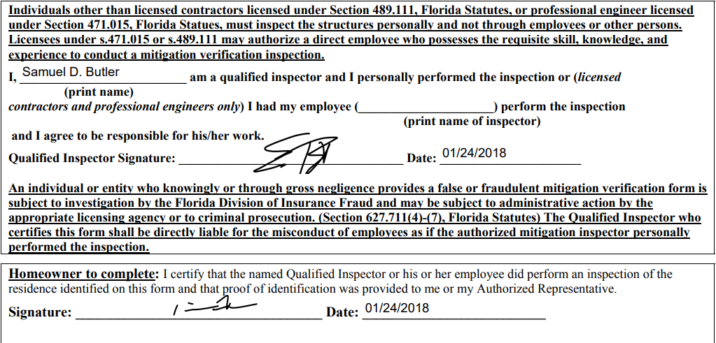

  - If the Wind Mitigation inspection is missing an insured signature, we should reach out to the insured to request their signature on the form and send them the inspection via DocuSign to complete. If the inspector needs to sign, have the insured contact the inspection company to have the inspector sign. If the inspection is lacking photographs of the property, request the insured to have those sent to processing@brightway.com. In all of these instances, push the suspense out 3 business days to Personal Service and make the action code Waiting on Documents. Once the completed form and/or photographs are received, continue on with Step 5.

Four-Point Inspections:

  - The Four-Point Inspection should have the inspector’s signature and license information on the inspection. If this is missing, follow the steps in 4c. to obtain the signature information from the inspection by sending advising the insured to obtain the inspector’s signature if the insured had the inspection completed. If the carrier had the inspection completed by one of their vendors, reach out to the carrier. Below is an example of the above referenced information.
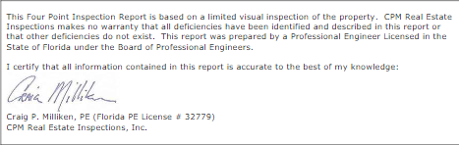

  - If the Four-Point Inspection is complete, continue on with Step 5.

- Follow the preferred method of the carrier (per the carrier profile) to submit the inspection per one of the following:

- If the carrier prefers documents to be uploaded, upload the completed Inspection form via the carrier website & create a Website activity from the existing suspense. Complete the open suspense notating that the inspection form was submitted via upload.
- If the carrier prefers documents to be emailed, email the completed inspection form to the carrier and create the Email activity. Complete the open suspense notating that the inspection form was submitted via Email.

- Attach copies of the documents to your Website activity or Email activity and use the corresponding doc type.
***(Wind Mitigation Inspection Doc Type = Wind Mitigation. Four Point Inspection Doc Type = Inspection).

- Before you save and close the activity, proceed to confirm the document is uploaded to the carrier site fully.

REMINDER*** Be sure to include the signature summary page if attaching a signed DocuSign document.

